**USER MANUAL for ALMA MINGLE**

**By Wall Street Devs**

Web Address: <https://se-alma-mingle-18js.vercel.app/>

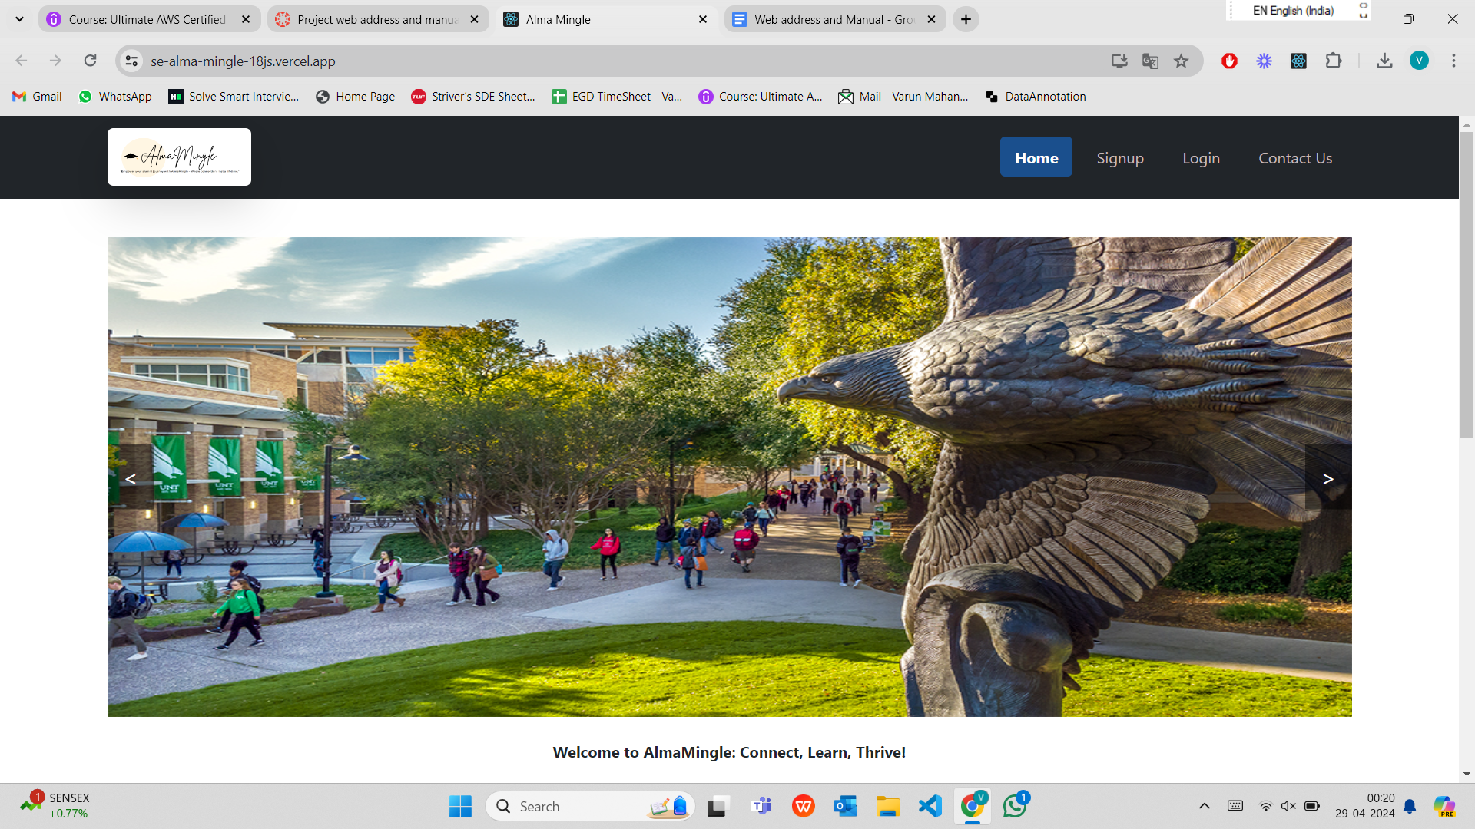

Figure 1

The above figure 1 is the home page of our application “**Alma Mingle**”. The home page consists of Images of the UNT and description regarding the webpage.

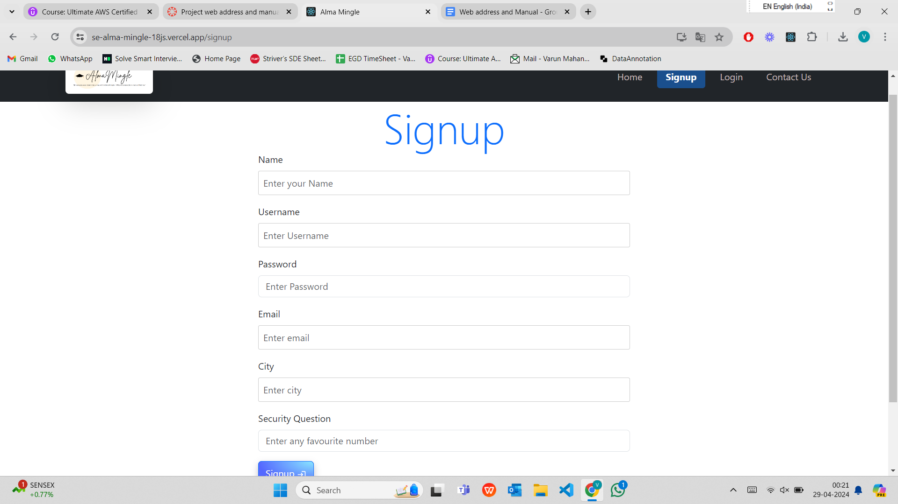

Figure 2

The above figure 2 shows the signup page, where the User can register their account only with their Unt mail id.

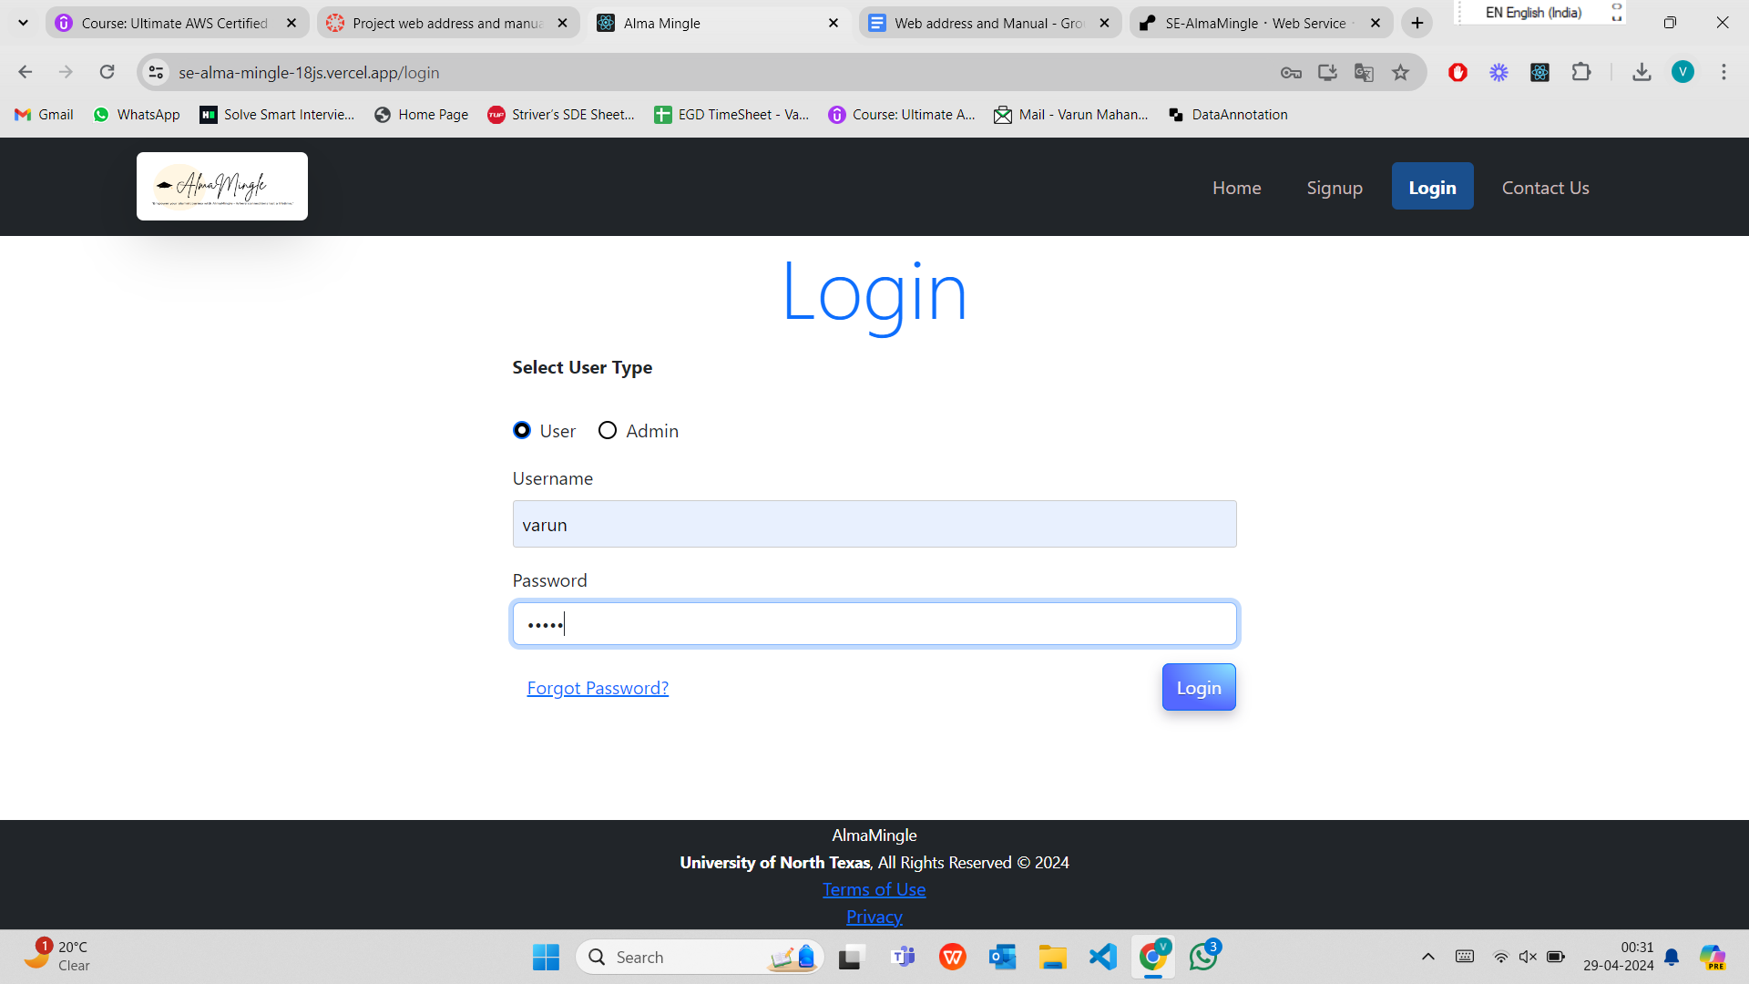

Figure 3

The above figure 3 shows the Login page, where the User needs to select User checkbox and can Login to their account by entering correct credentials.

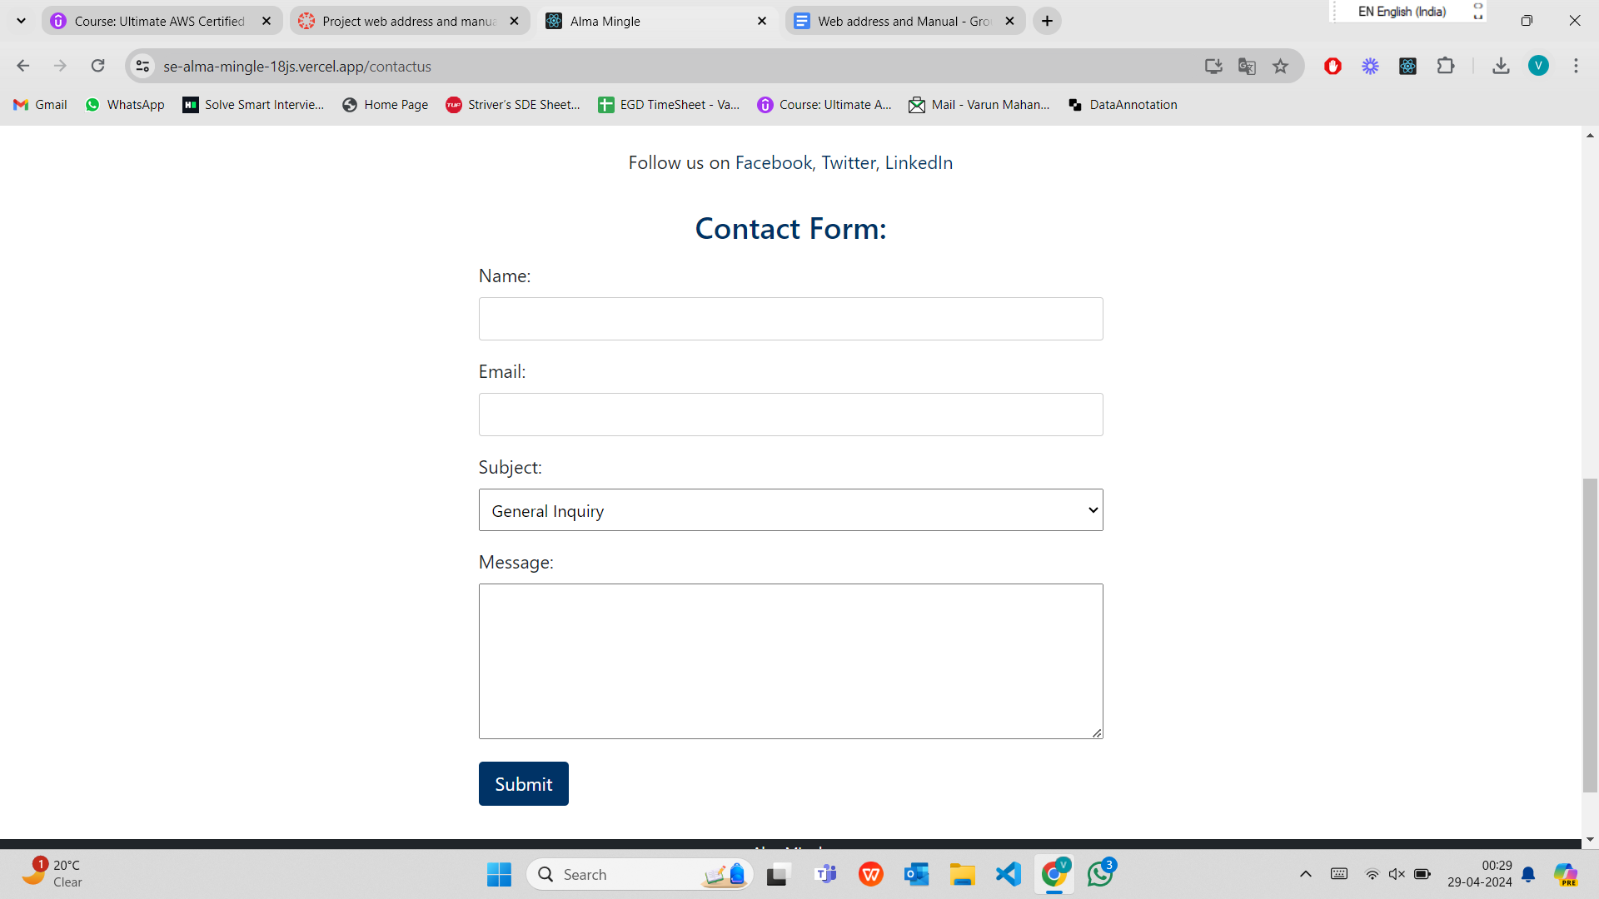

Figure 4

The above figure 4 shows the Contact Us page which is present to the right side of the Login navbar. The user can enter the above form for inquiries and the admin receives all these inquires and can contact to the user.

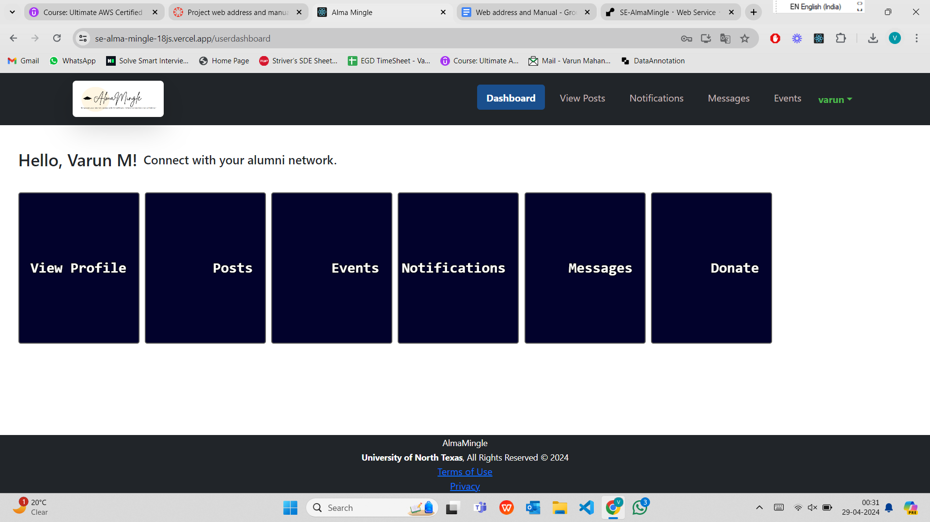

Figure 5

The figure 5 shows the Userdashboard after the user logins to their account. He can see all the features, add/view posts, Notifications, messages, Events, View Profile, Donation, Change Password.

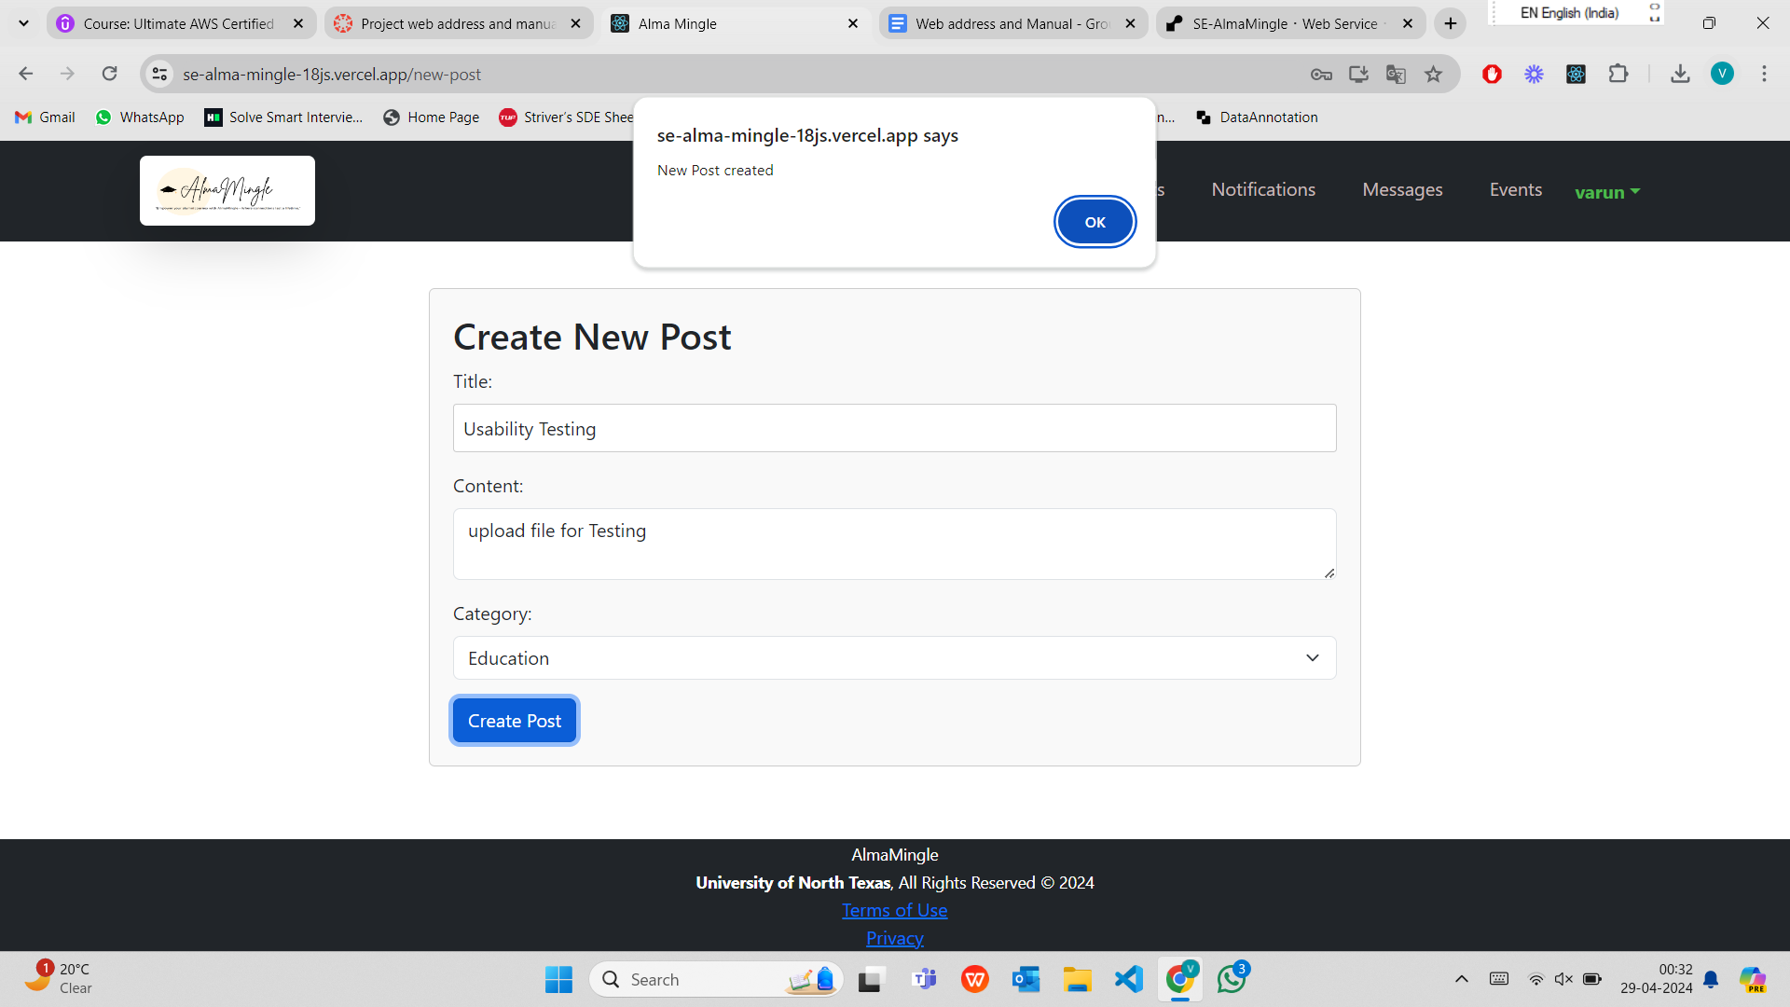

Figure 6

After user creates a new post they get a pop up message confirming the post creation as shown in the figure 6

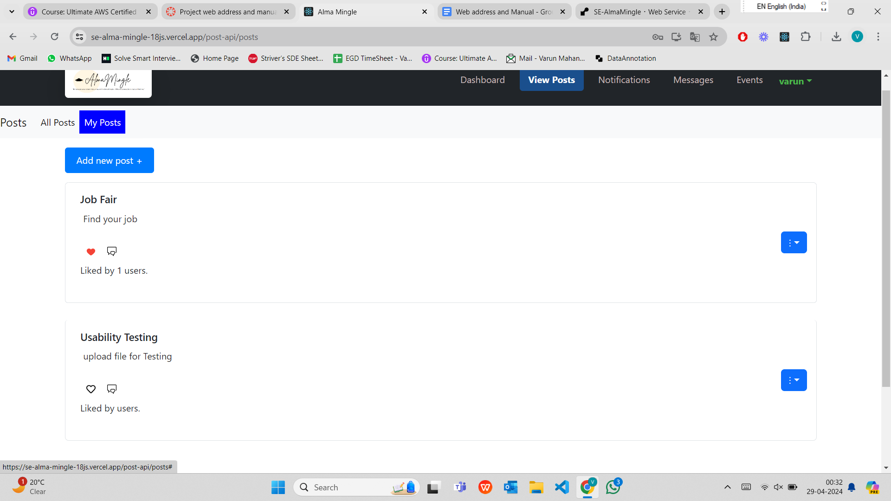

Figure 7

In the figure 7, in the My Posts section, the user sees the posts that are created only by him. Users can edit or delete the post also if they want by clicking on the blue dropdown to the right side of the post.

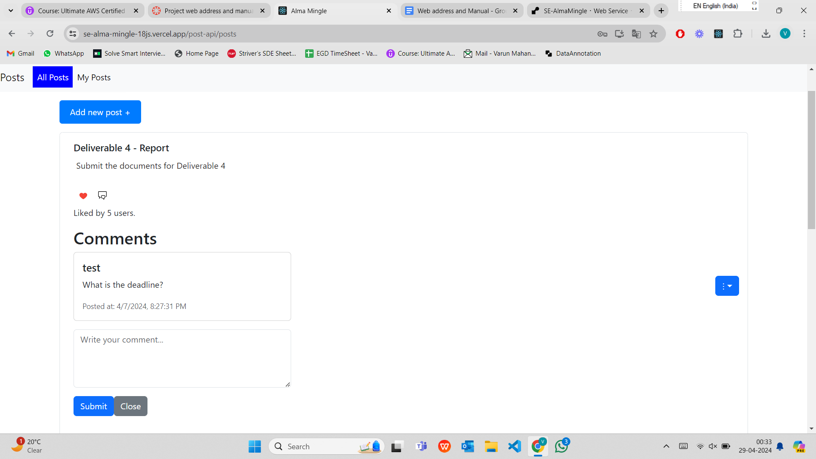

Figure 8

In the figure 8 above, in the All Posts section all the posts that are created by other users are visible. The other users can Like the post, Comment the post and Report the post if they find it inappropriate.

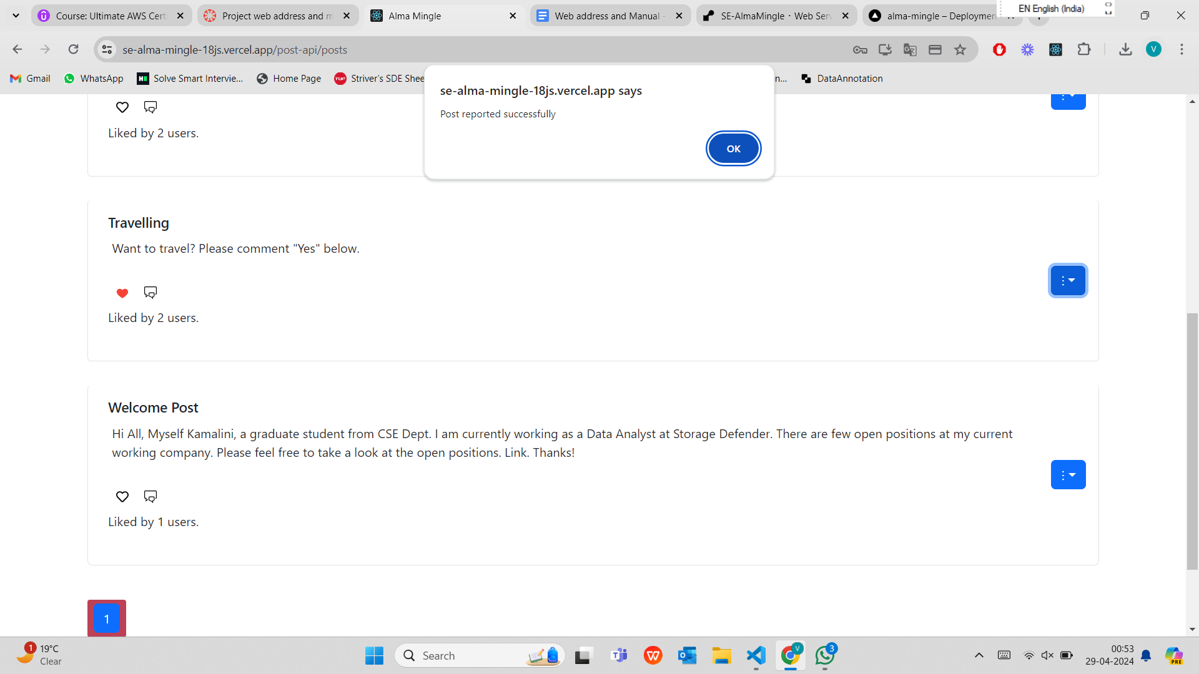

Figure 9

In figure 9 above shows the popup message confirming the user after he reported the post.

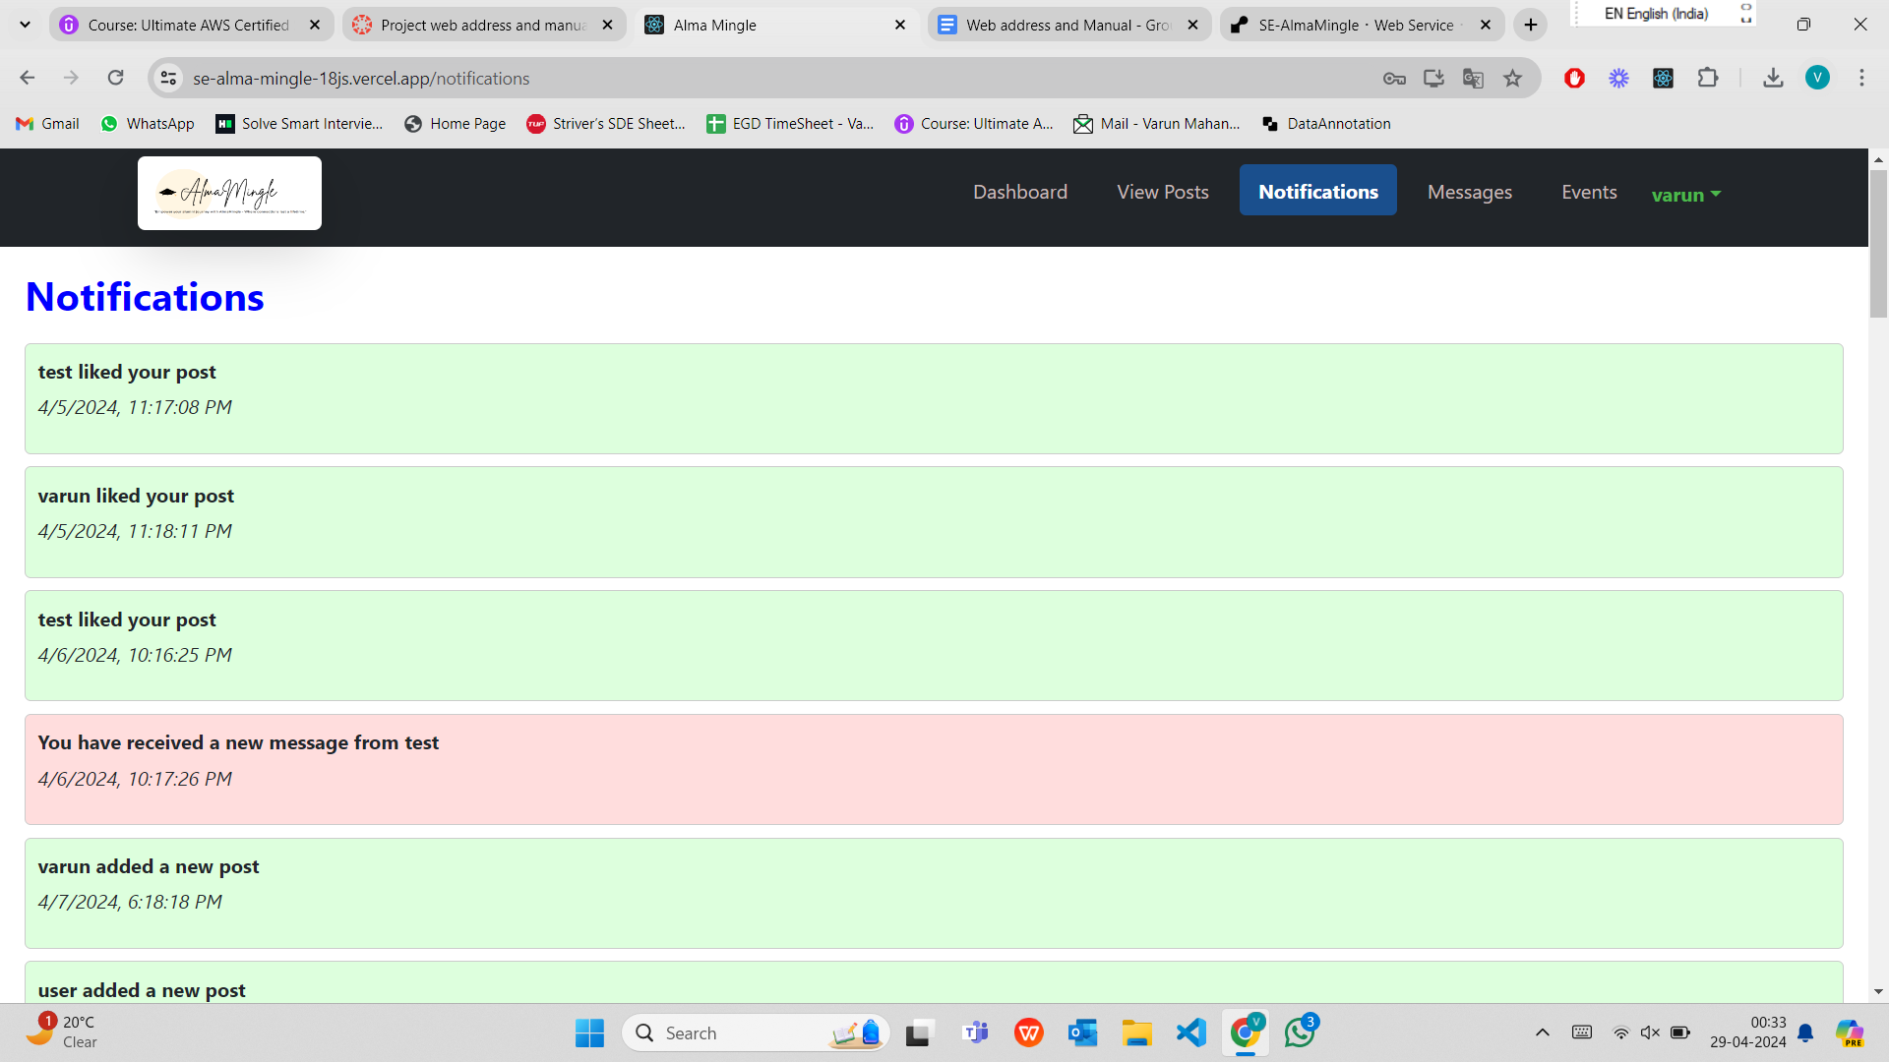

Figure 10

Figure 10 shows Notification page that are received to the user. Notifications like when the post is liked, when the post is commented, when the user receives a message from user, admin and when the users post is deleted by admin.

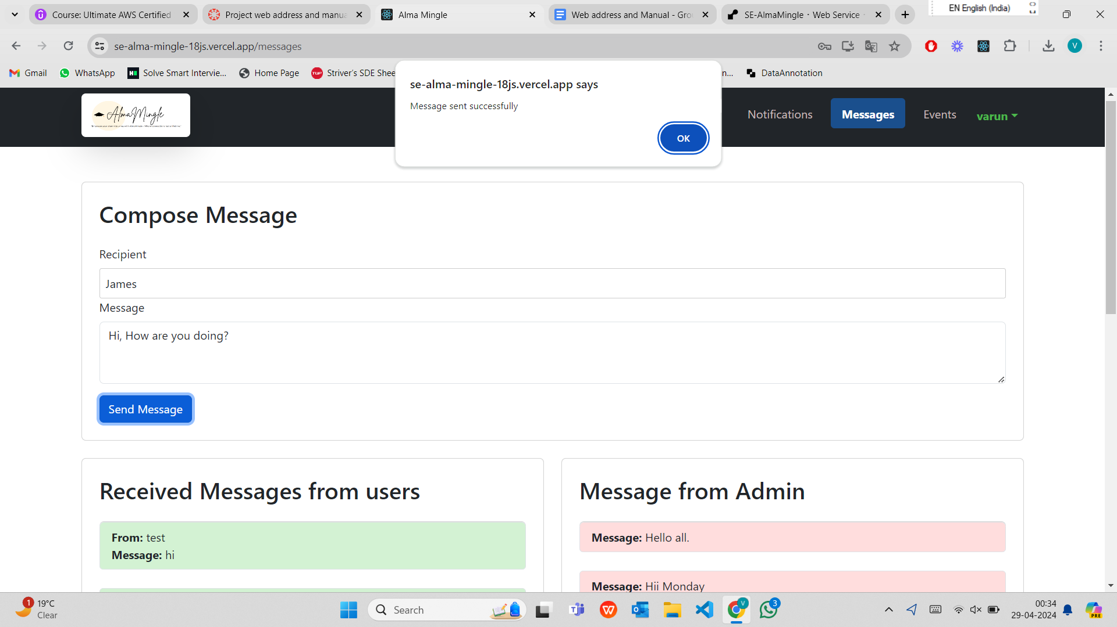

Figure 11

Figure 11 shows the Message page, the user can send messages to other users. The figure shows a pop up message confirming to the user regarding the message sent confirmation.

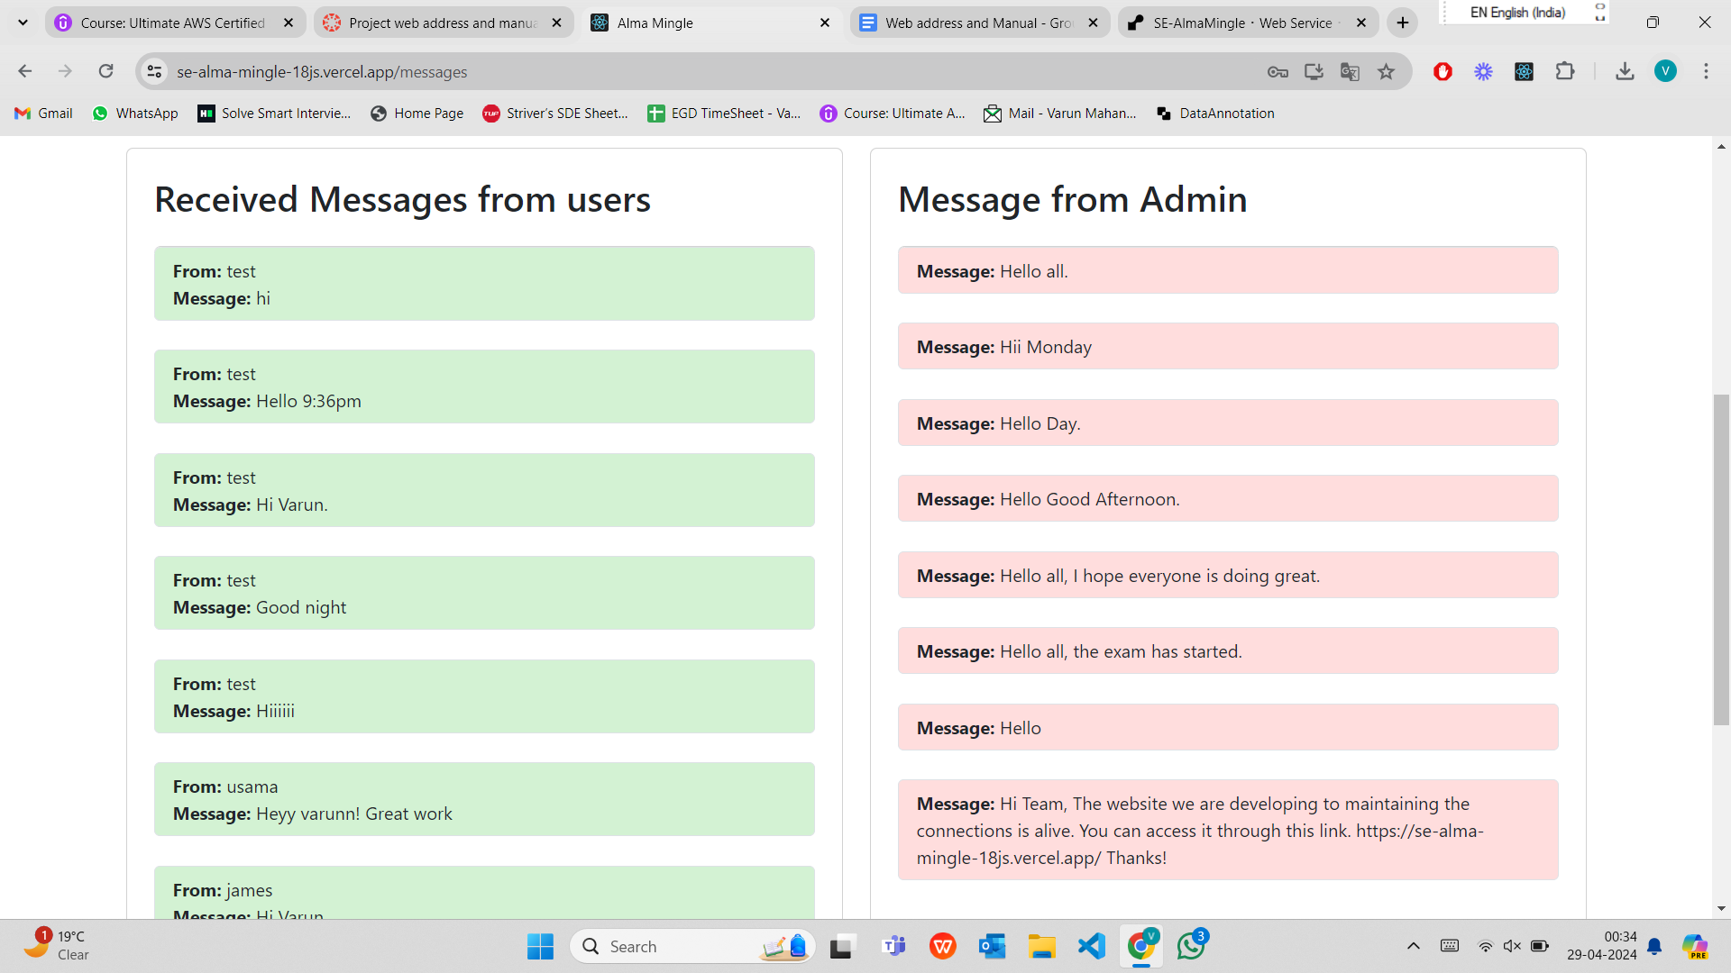

Figure 12

The figure 12 shows the messages received from other users to the left side and the messages received from admin to the right side.

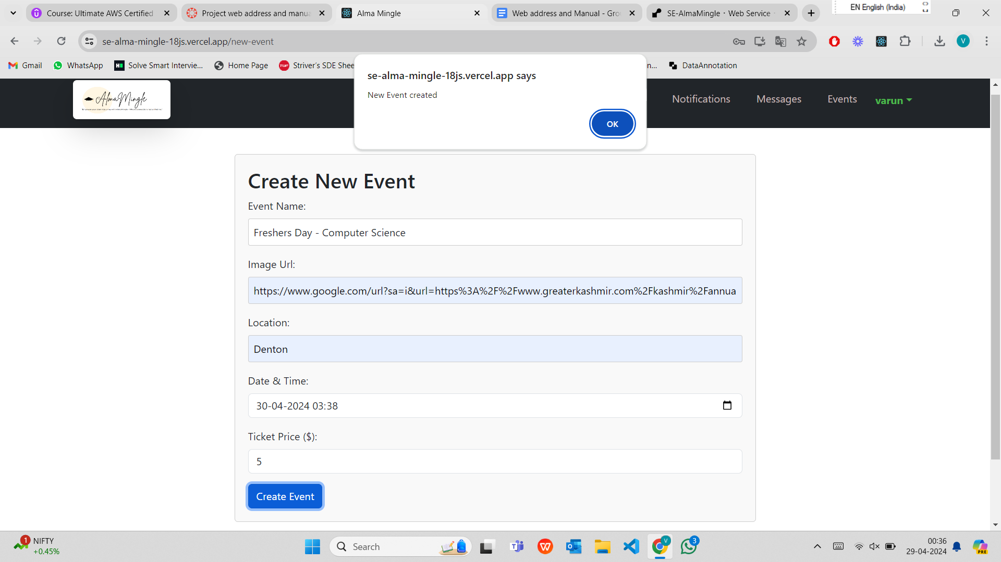

Figure 13

Figure 13 shows the pop up message confirming the user after creation of new event by entering the details.

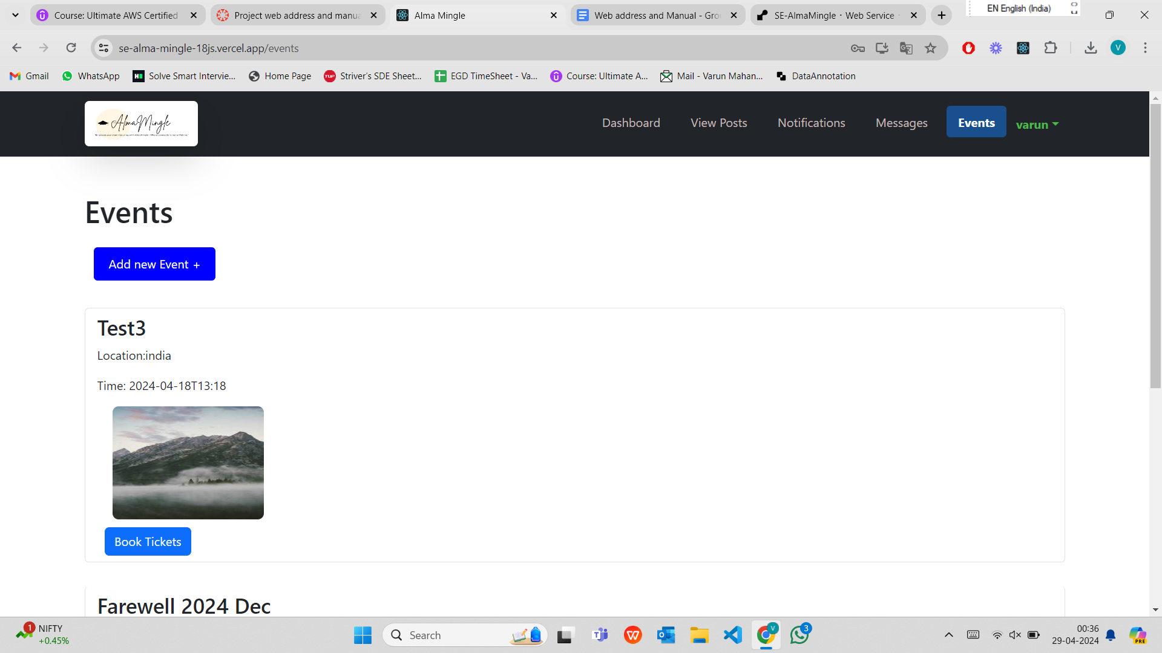

Figure 14

Figure 14 shows all the events created by other users. Other users can register to the event by booking tickets.

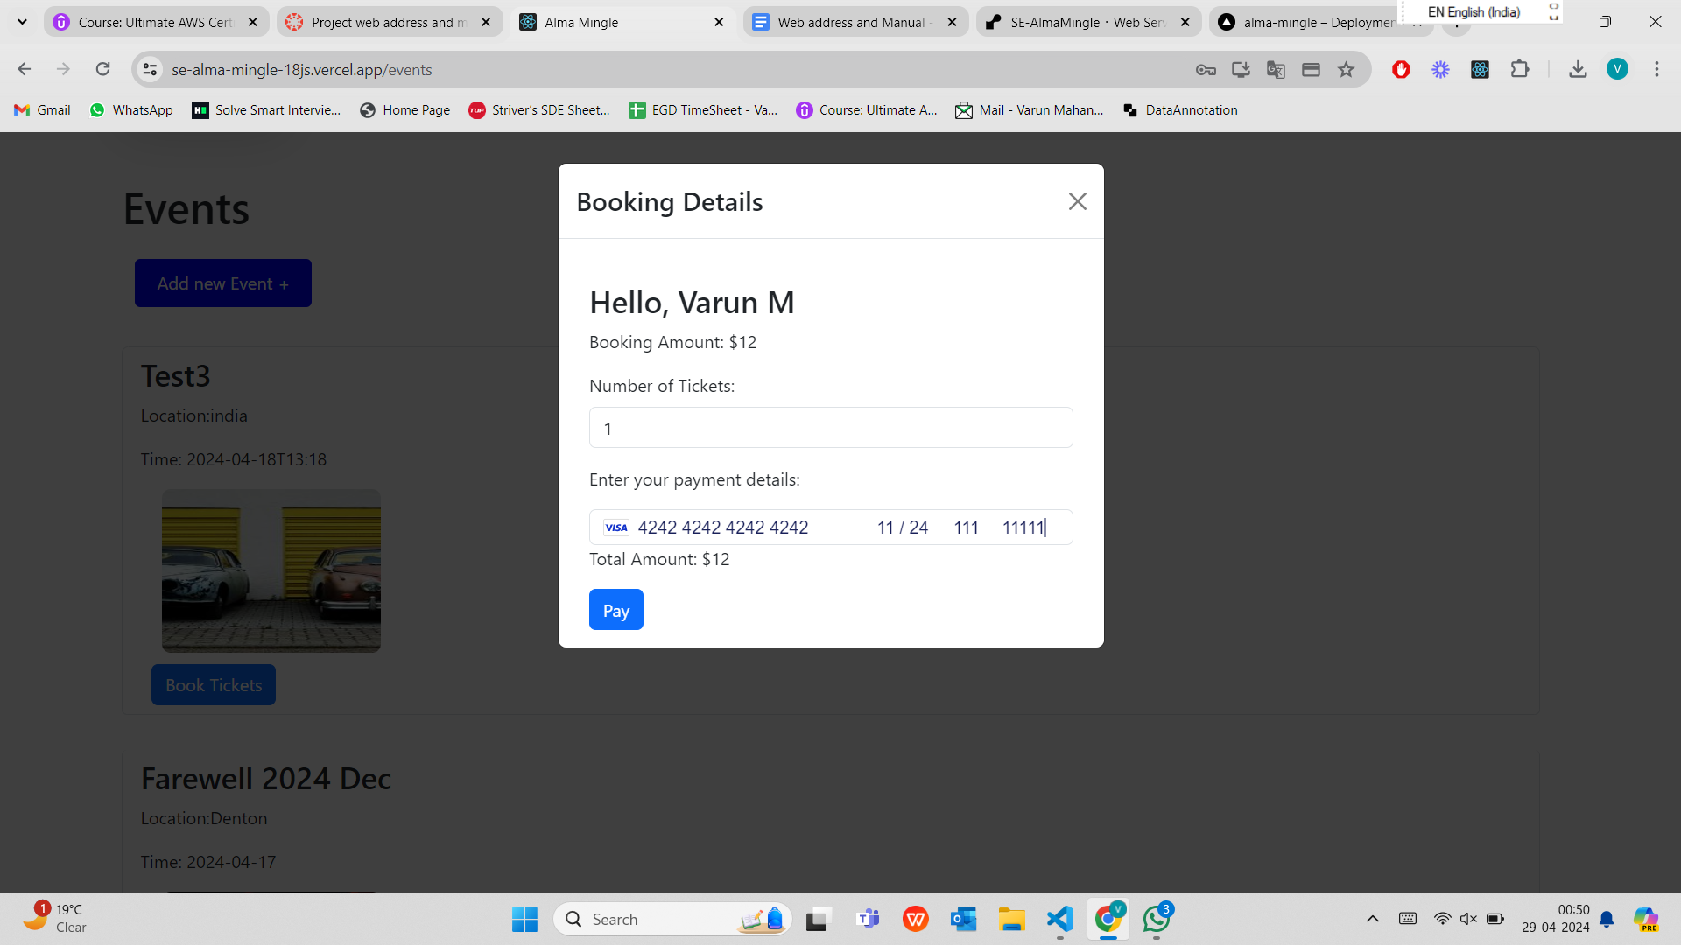

Figure 15

Figure 15 shows the modal when the “Book Tickets” button is clicked. The user can enter details of the card and book the number of tickets they wants.

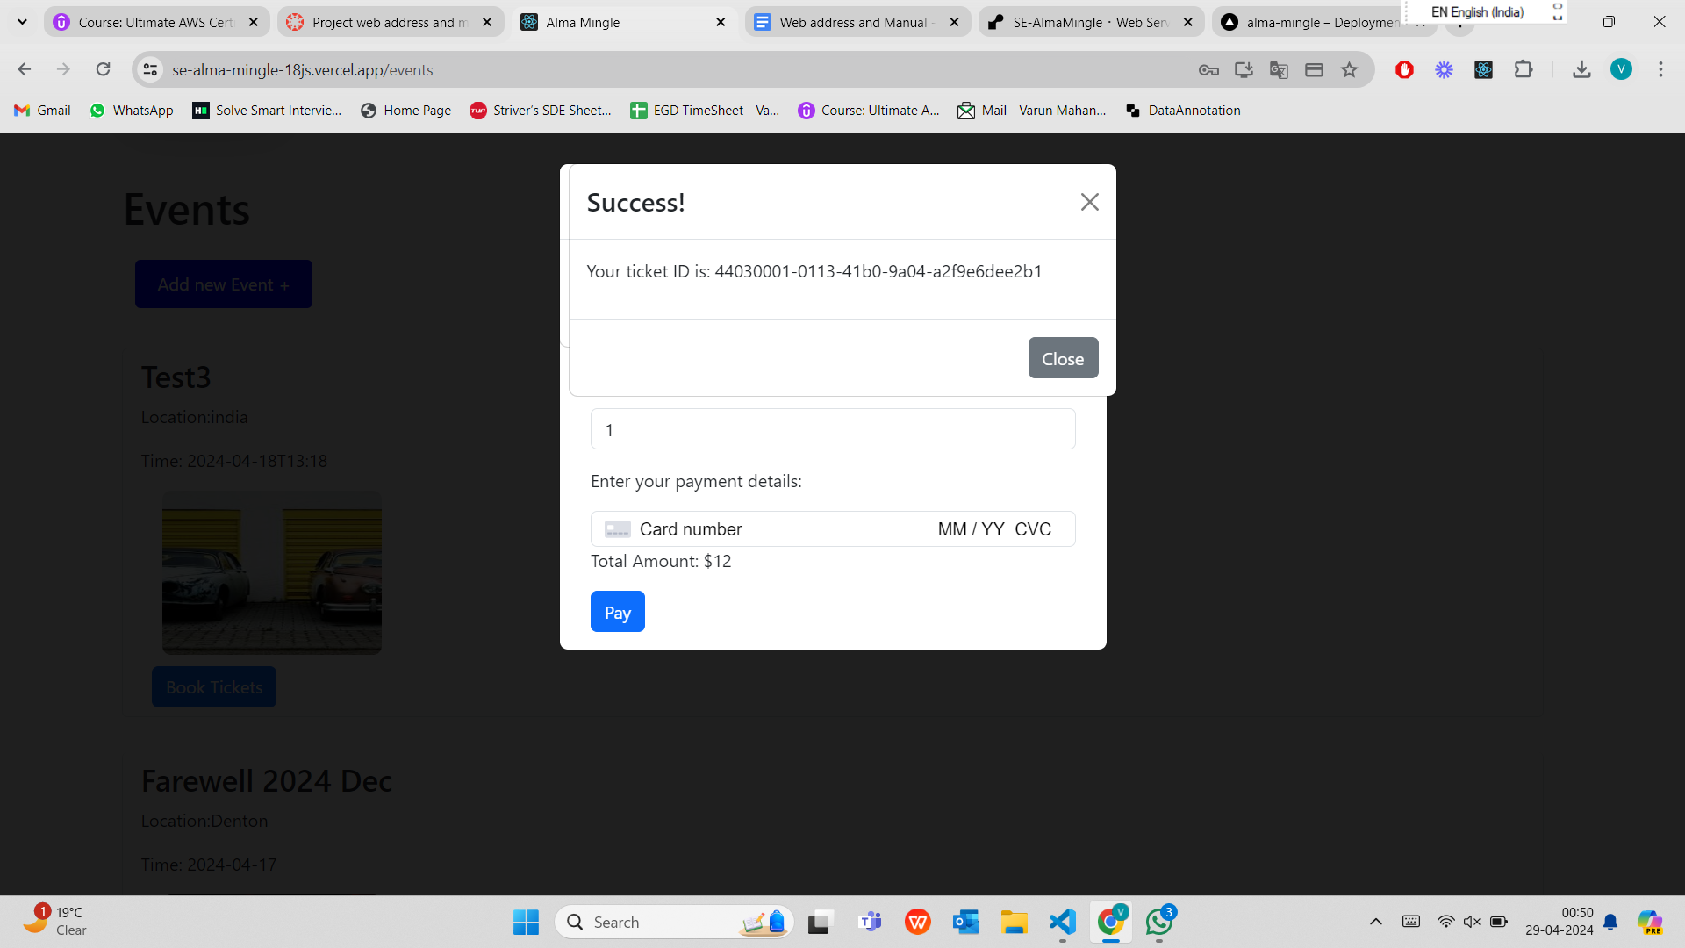

Figure 16

Figure 16 shows the Ticket ID sent to user after the payment is success.

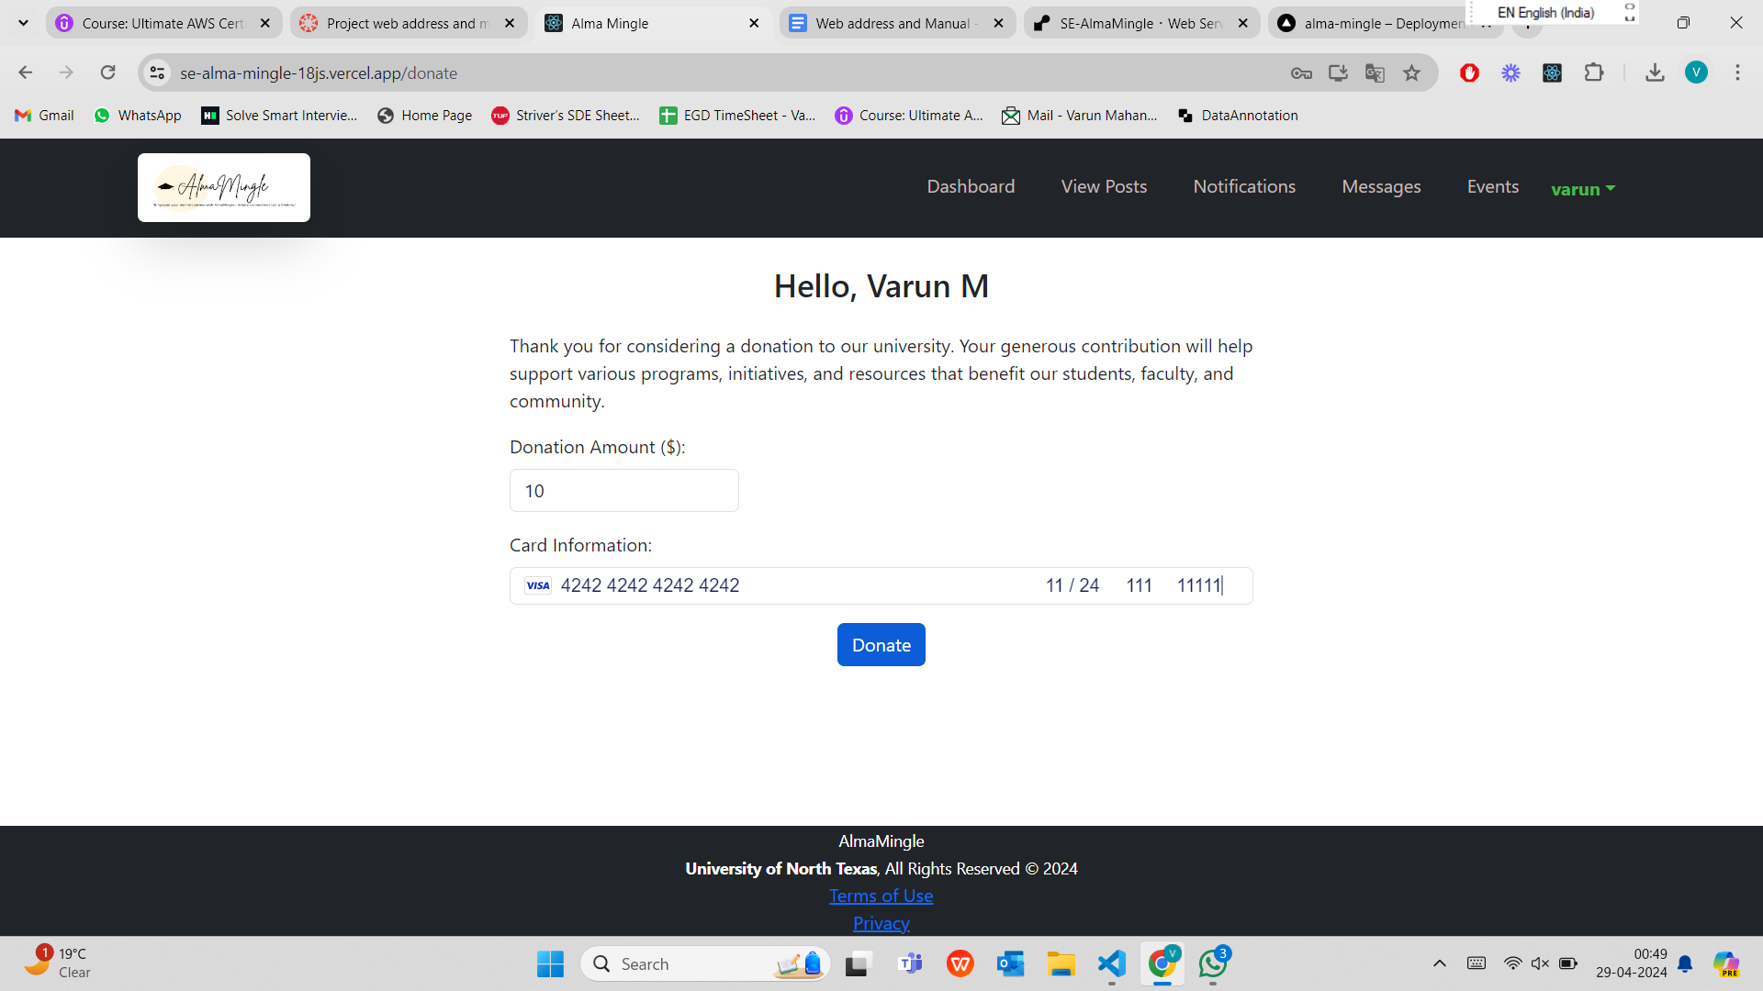

Figure 17

Figure 17 is the Donation page which is available on the userdashboard. The user can enter the amount they want to donate and enter the card details and click donate.

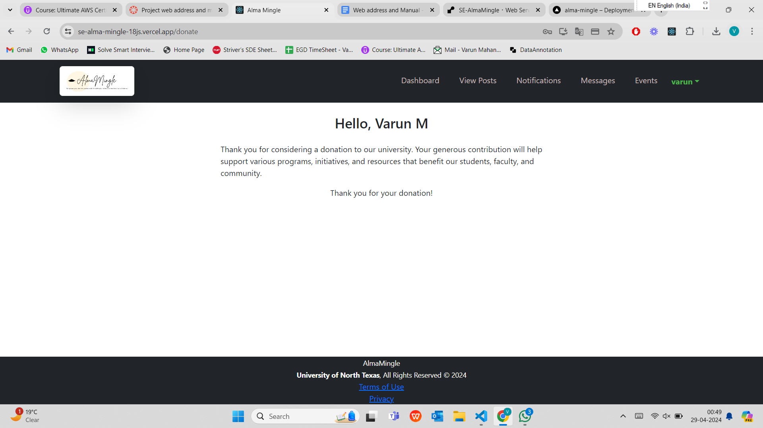

Figure 18

Figure 18 shows the Confirming page to the user after the donation payment is success full.

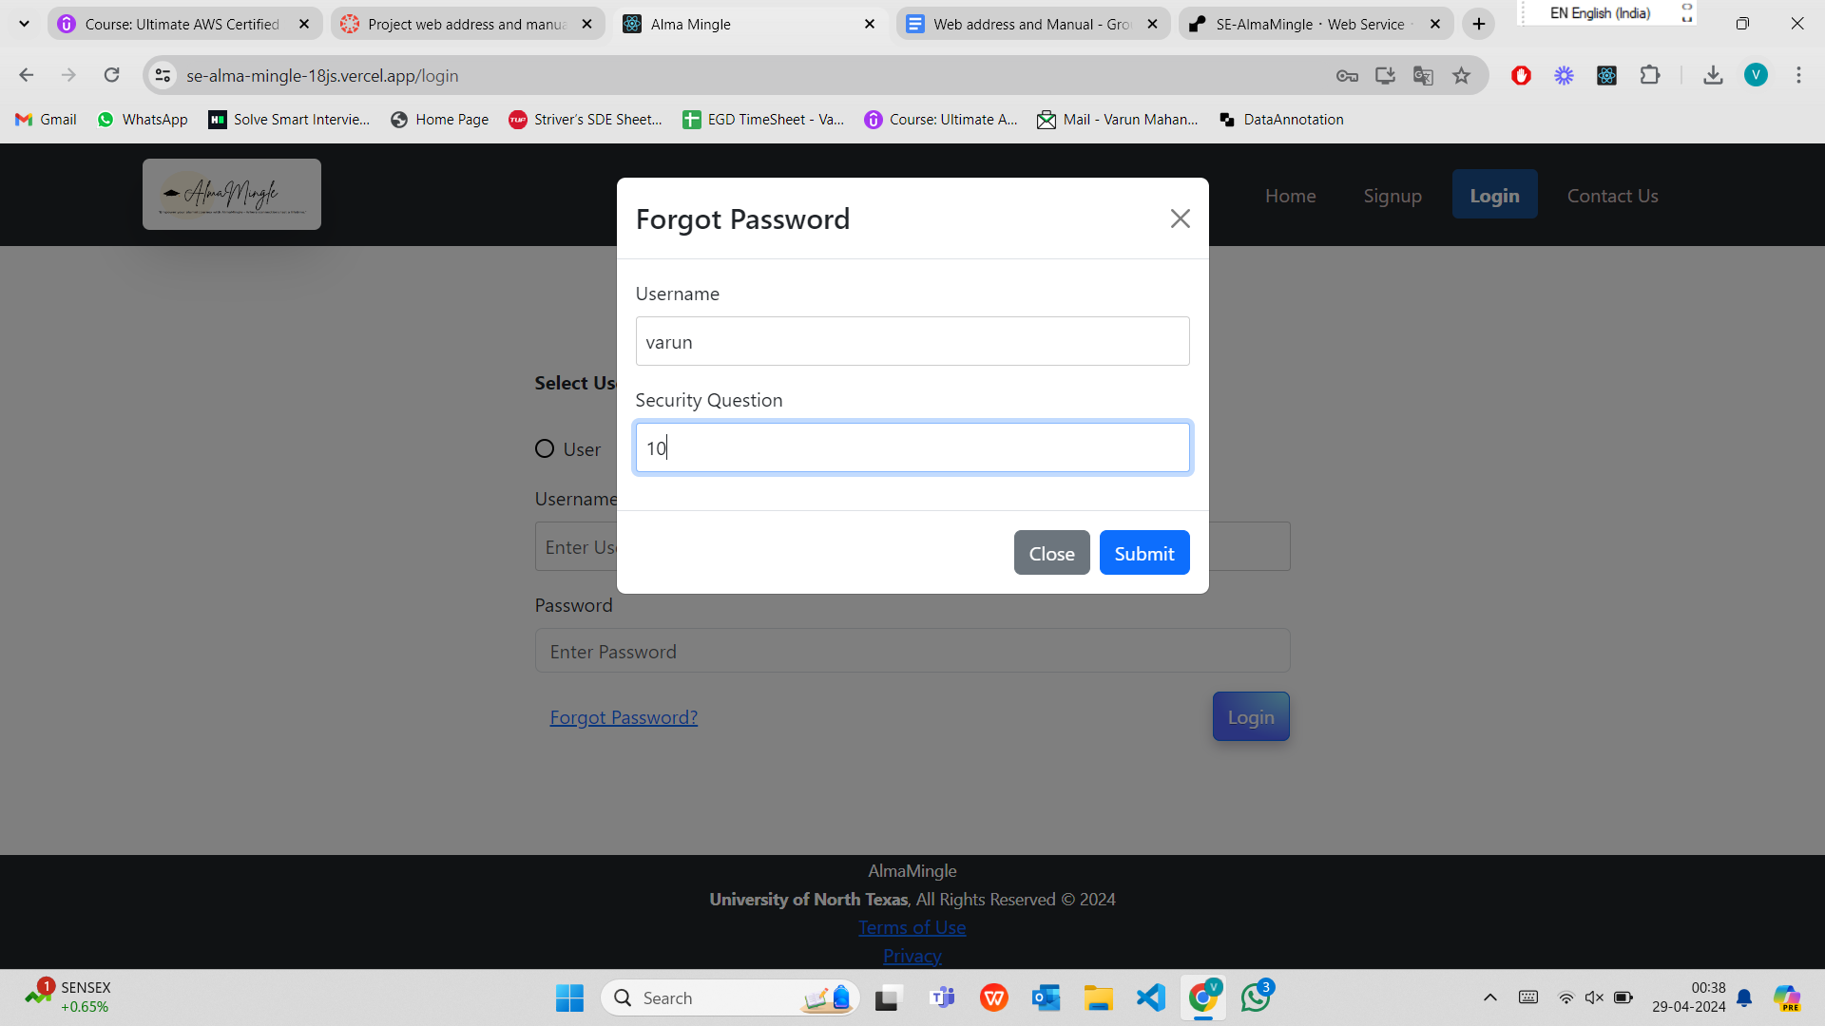

Figure 19

Figure 19 shows the forgot password modal which is available on the login page. If the user forgets password then he can click on forgot password and enter the questions asked. Even if the user forgets the security question, then they can contact admin on the contact us page by filling the form. After the user enters the correct details and then clicks submit, the screen is navigated to Change Password screen as shown in the figure 20.

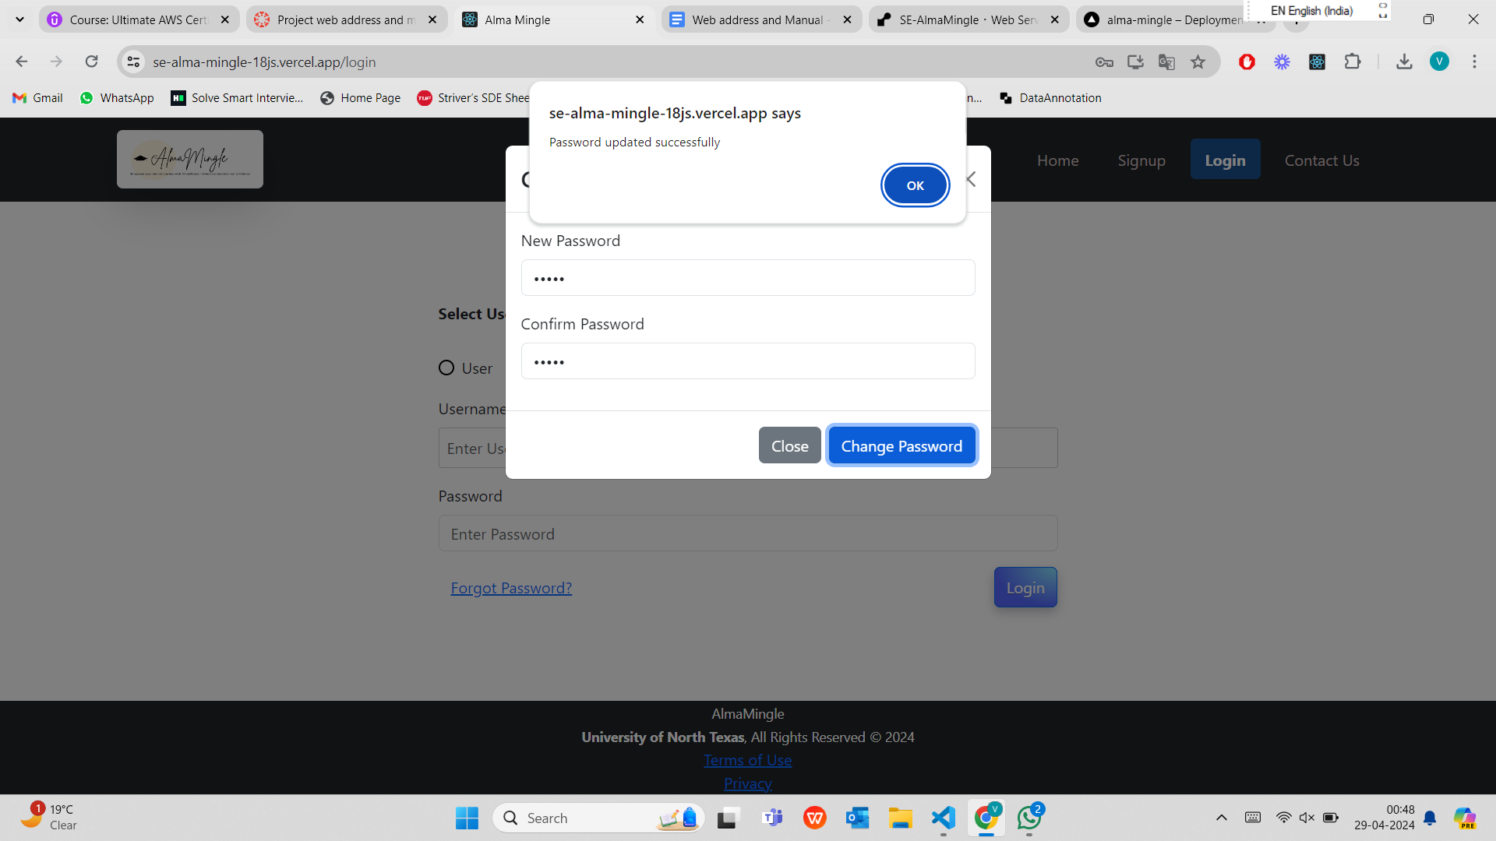

Figure 20

In figure 20, after user enters the new password and confirm password and clicks on change password, the pop up message confirming the Password updated successfully is appeared to the user.

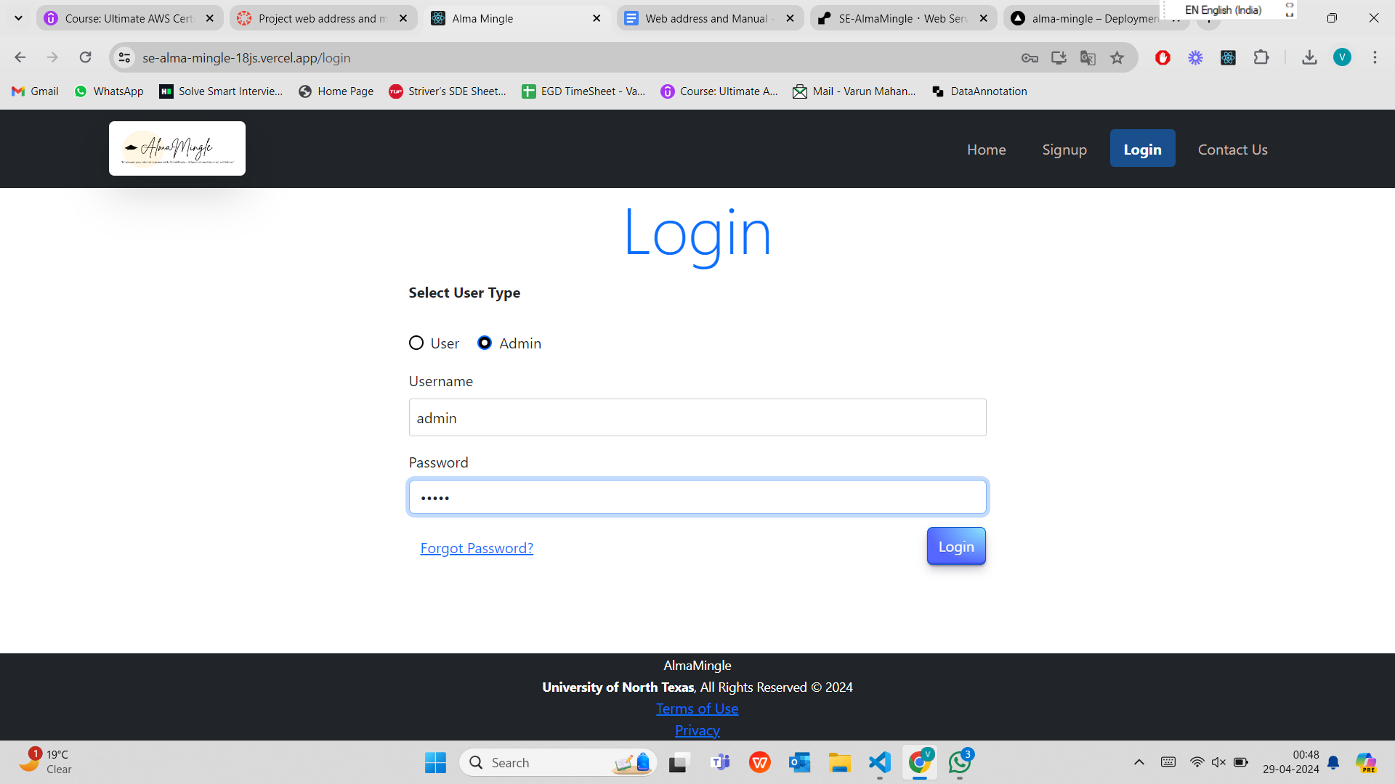

Figure 21

Now the admin can login to the application by entering the admin details. Admin credentials are manually created in the database. One of the admins credentials are ( Username : admin, Password : admin ) for testing purposes.

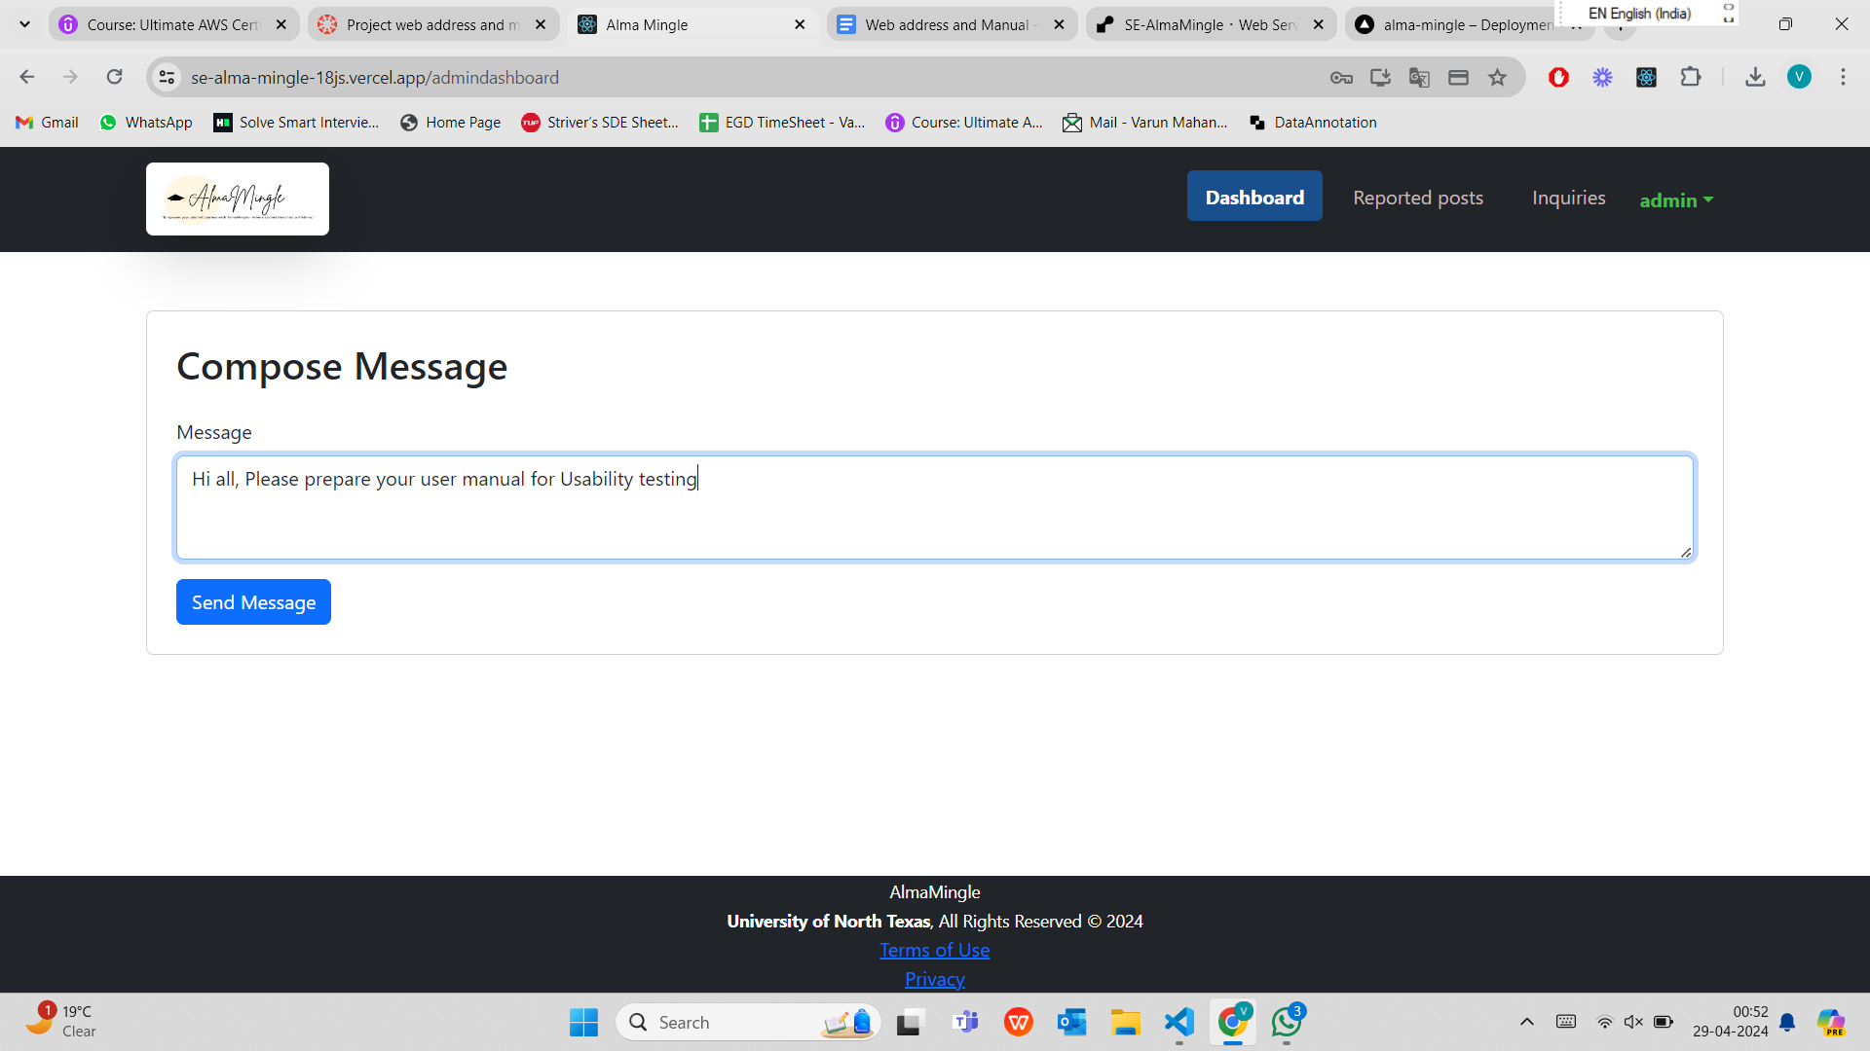

Figure 22

Figure 22 shows the Admin dashboard consisting of Composing messages to all the users. Seeing the reported posts and deleting them if required, Inquires.

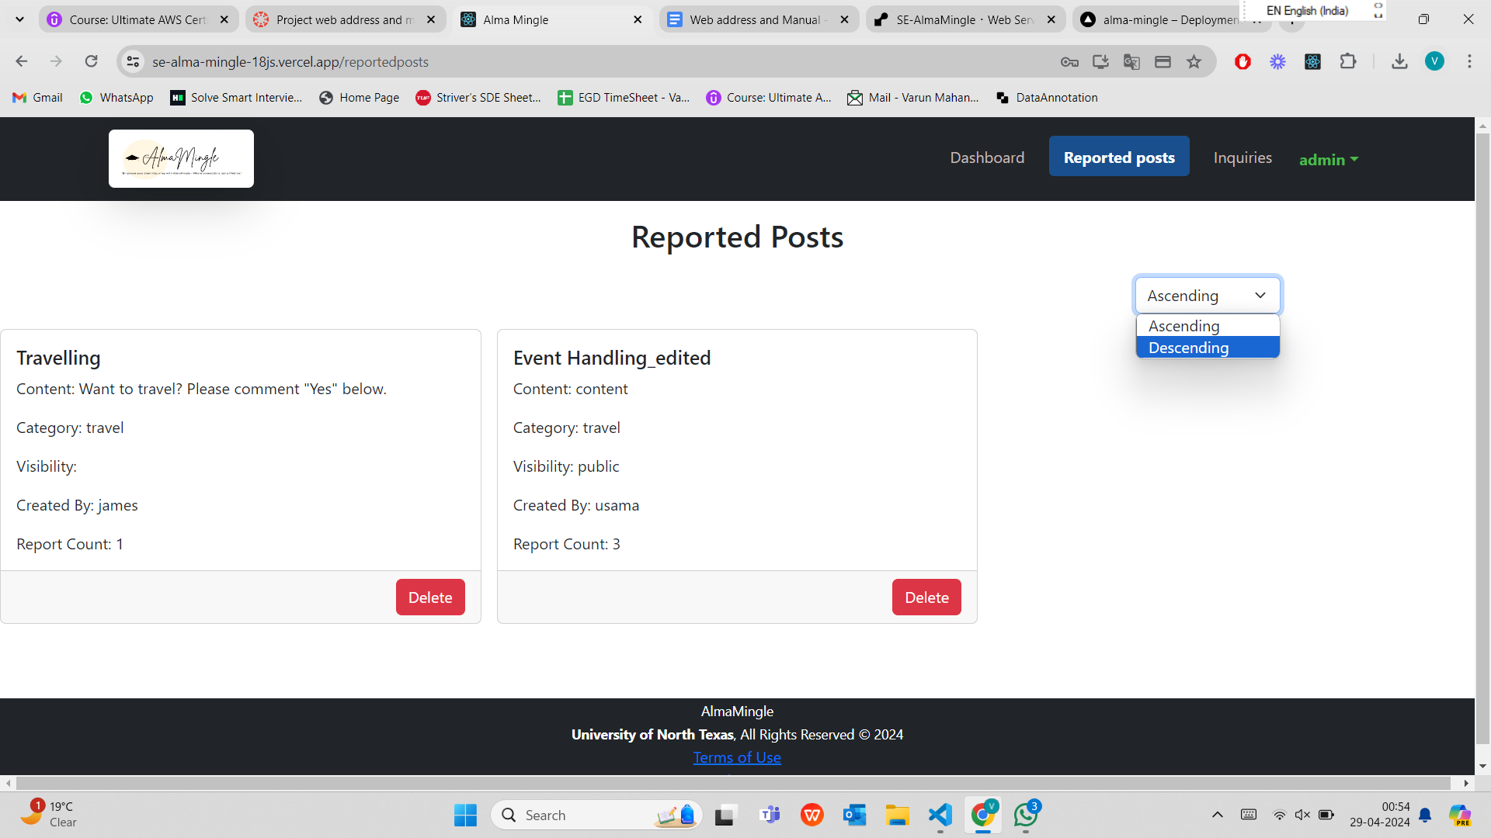

Figure 23

Figure 23 shows the reported posts that are reported by other users. If a particular posts is reported by 2 or more users then the Report Count is increased for that post. The posts can be ordered ascending or descending based on the report count.

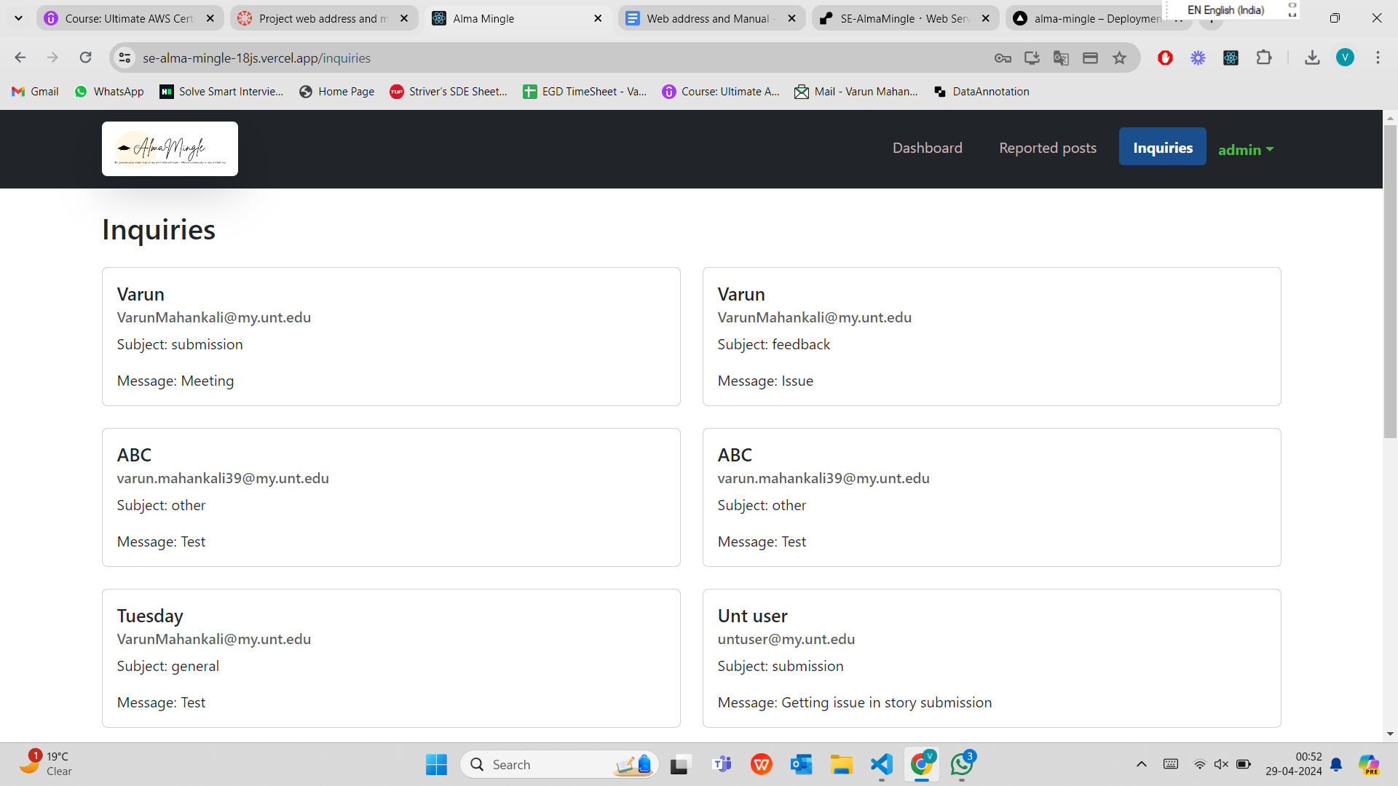

Figure 24

Figure 24 shows all the inquiries that are from the user. Admin can contact user through email and resolve their inquiries.